**Week 05: Team Activity - SQL Select Practice**

**Instructions**

* Each person will lead the discussion that asks a question about the data, then lead the creation of a SQL statement that provides the answer. Select a team member to begin. This team member will:
  1. Write a question to answer. The questions should include questions that will require,
     + WHERE conditions
     + Table Joins
     + Aggregates

NOTE: You do not need to use all clauses in each question. Just make sure that all the clauses get covered during the session.

* 1. Using MySQL Workbench, write a query to answer the selected question. The team members should help and discuss but the question leader types the query.
  2. When you are confident you have the correct answer, record the following information in the Word document.
     + - The question being asked.
       - Team member name that lead the discussion for this question.
       - SQL query used to answer the question.
       - Query results, either as a screen shot or table.
  3. Select another team member to lead the discussion and repeat until you have spent 60 minutes.

A)

1. Question #1: -- How many emails are there in the cities that have 'ent' in their city name?
2. Team member: Everyone
3. Query used: See Screenshot
4. Query results: See screenshot

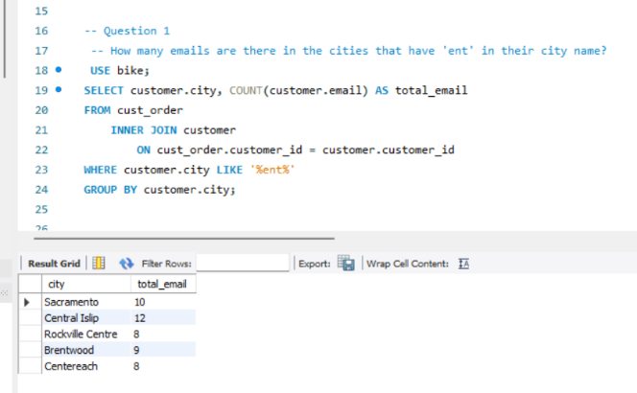

B)

a. Question #2: -- What are the total number of subscriptions per magazine with a price greater than $12.50.

b. Team member: Everyone

c. Query used: See screenshot

4. Query results: See screenshot

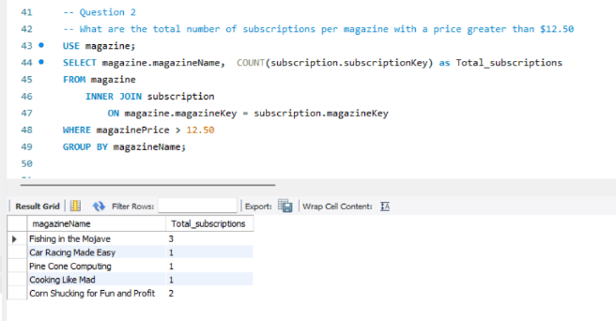

C)

a. Question #3: -- What is the average magazine price per city with a subscription greater than 12 months old.

b. Team member: Everyone

c. Query used: See screenshot

d. Query results: See screenshot

